**LAB 07**

**POISSION DISTRIBUTION**

**Aim: To analyze Poission Distribution**

**New-TERM:**

1. **dpois(): This function is used to calculate the probability mass function (PMF) of a Poisson distribution. It calculates the probability of getting a specific number of events occurring in a fixed interval of time or space. In the code, it is used to calculate the probabilities for different scenarios, such as at least 2 defectives (sum(dpois(2:n, lambda))), exactly 2 defectives (dpois(2, lambda)), and at most 2 defectives (sum(dpois(0:2, lambda))).**

**Input:**

**# Poission Distribution - b,p,q,r**

**# Number of trails**

**n=20**

**n**

**#Probability for success**

**ps=0.02**

**#poisson parameter**

**lambda = n*ps**

**lambda**

**#I0)at least 2 defectives**

**p1=sum(dpois(2:n,lambda))**

**p1**

**#(I) number of boxes containing at least one defective item out of a total sample size of 1000 items.**

**round(1000*p1);**

**#(ii)at least 2 defectives**

**p2=dpois(2,lambda);**

**p2**

**#(iii) Number of boxes containing exactly**

**round(1000*p2);**

**#(iv)at most 2 defectives**

**p3=sum(dpois(0:2,lambda))**

**p3**

**# plot the distribution**

**x1=0:n;**

**px1=dpois(x1,lambda);**

**plot(x1,px1,type="h",xlab="values of x");**

**# mean of distribution or lambda**

**Ex1 = weighted.mean(x1,px1);**

**Ex1**

**# variance of x**

**var1 = weighted.mean(x1*x1,px1)-(weighted.mean(x1,px1))^2;**

**var1**

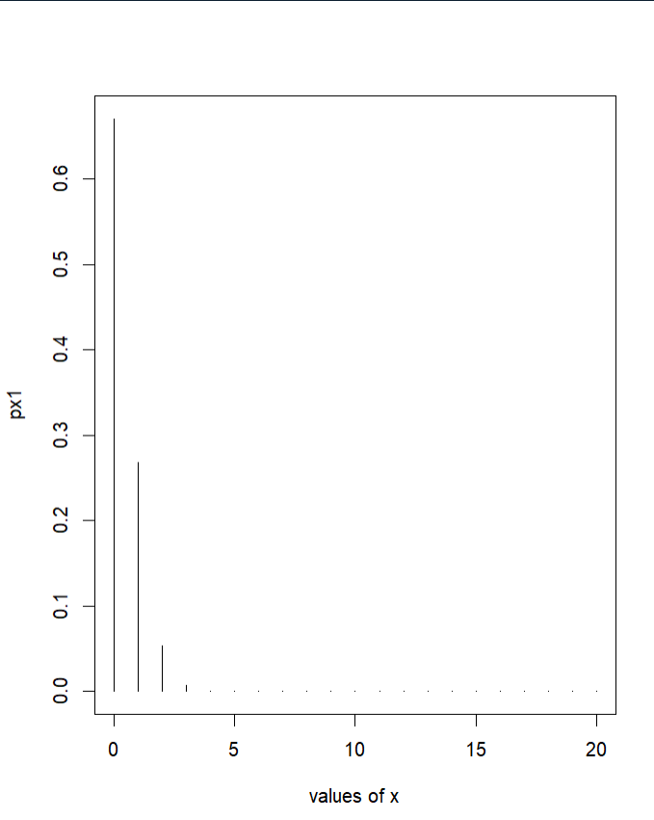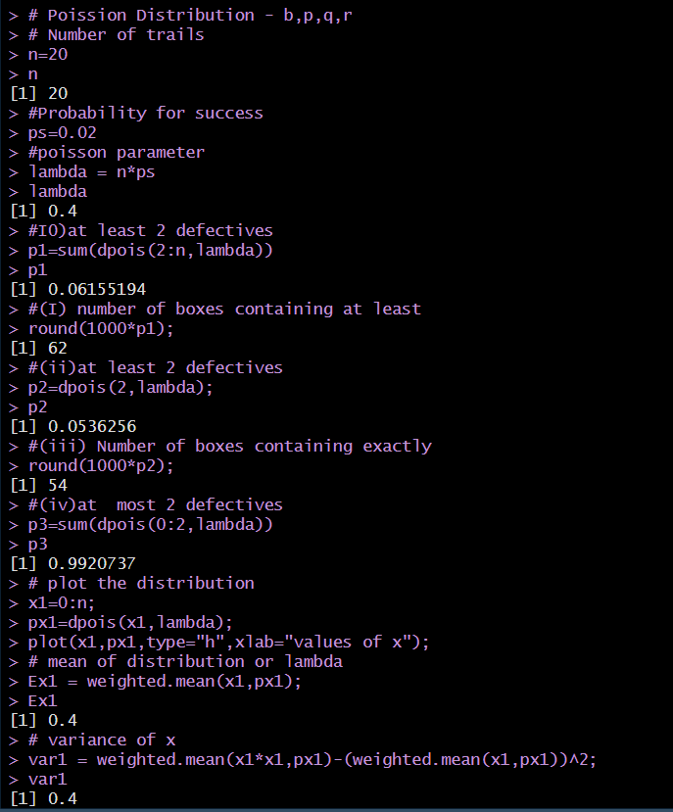**OUTPUT:**

**Example 2:**

**# This code calculates the probability of getting 2 or fewer successes in 4 trials,**

**# where the probability of success on each trial is 0.02.**

**n = 4 # number of trials**

**p = 0.02 # probability of success on each trial**

**# calculates the probability of getting exactly 2 successes.**

**dpois(2, n, p)**

**# creates a vector of values from 0 to 4.**

**x = 0:n**

**# creates a vector of probabilities for each value in x.**

**px = dpois(x, n, p)**

**# calculates the expected value of x.**

**Ex = weighted.mean(x, px)**

**# calculates the variance of x.**

**varx = weighted.mean(x*x, px) - (weighted.mean(x, px))^2**

**#plots the probability mass function of x.**

**plot(x, px, type="h", xlab="values of x", ylab="values of y", main="Visualization")**

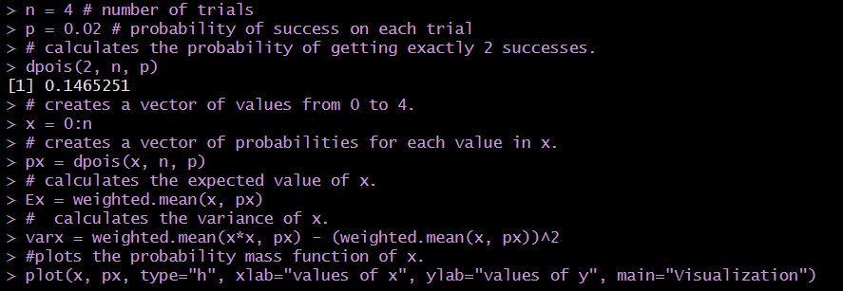**OUTPUT:**

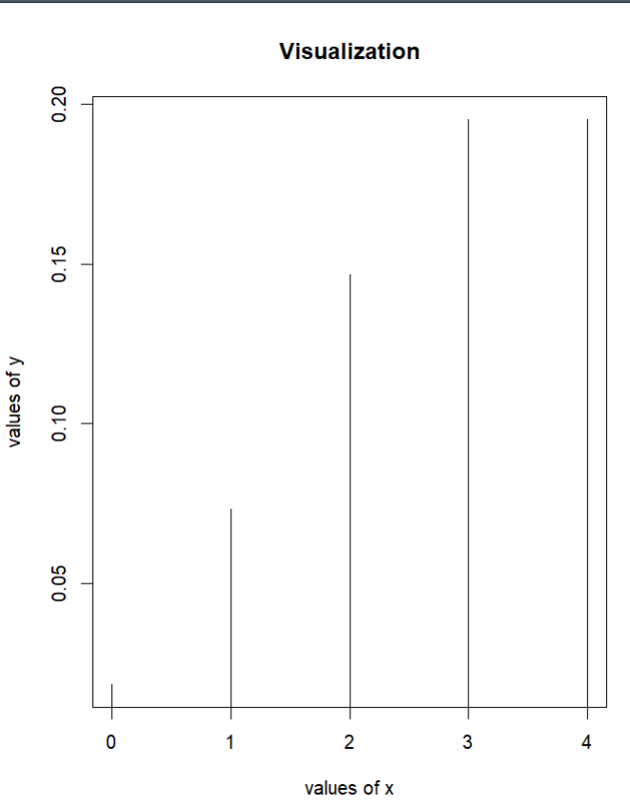

**INFERENCE:**

**Variance calculated using weighted mean function and found poisson distribution values for different ranges of a.**

**\*\*\*\*\*\*\*\*\*\*\*\*\*\*\*\*\*\*\*\*\*\*\*\*\*\***